דוח מכין 4

בר ירושלמיאן 318445939

בן אפרת 319001319

15.5.23

Q1

Convert Intensity Image to Binary Image Using Level Threshold

Read a grayscale image into the workspace.

I = imread('coins.png');

Calculate a threshold using graythresh. The threshold is normalized to the range [0, 1].

level = graythresh(I)

level = 0.4941

Convert the image into a binary image using the threshold.

BW = imbinarize(I,level);

Display the original image next to the binary image.

imshowpair(I,BW,'montage')



Calculate Centroids and Superimpose Locations on Image

Read a binary image into workspace.

BW = imread('text.png');

Calculate centroids for connected components in the image using regionprops. The regionprops function returns the centroids in a structure array.

s = regionprops(BW,'centroid');

Store the *x*- and *y*-coordinates of the centroids into a two-column matrix.

centroids = cat(1,s.Centroid);

Display the binary image with the centroid locations superimposed.

imshow(BW)

hold on

plot(centroids(:,1),centroids(:,2),'b*')

hold off



*Copyright 2015 The MathWorks, Inc.*

Label Components Using 4-connected Objects

Create a small binary image.

BW = logical ([1 1 1 0 0 0 0 0

1 1 1 0 1 1 0 0

1 1 1 0 1 1 0 0

1 1 1 0 0 0 1 0

1 1 1 0 0 0 1 0

1 1 1 0 0 0 1 0

1 1 1 0 0 1 1 0

1 1 1 0 0 0 0 0]);

Create the label matrix using 4-connected objects.

L = bwlabel(BW,4)

L = 8×8

1 1 1 0 0 0 0 0

1 1 1 0 2 2 0 0

1 1 1 0 2 2 0 0

1 1 1 0 0 0 3 0

1 1 1 0 0 0 3 0

1 1 1 0 0 0 3 0

1 1 1 0 0 3 3 0

1 1 1 0 0 0 0 0

Use the find command to get the row and column coordinates of the object labeled "2".

[r, c] = find(L==2);

rc = [r c]

rc = 4×2

2 5

3 5

2 6

3 6

*Copyright 2015 The MathWorks, Inc.*

Calculate Area of Objects in Binary Image

Read a binary image and display it.

BW = imread('circles.png');

imshow(BW)



Calculate the area of objects in the image.

bwarea(BW)

ans = 1.4187e+04

*Copyright 2017 The MathWorks, Inc.*

Select Objects in Binary Image

Select objects in a binary image and create a new image containing only those objects.

Read binary image into the workspace.

BW = imread('text.png');

Specify the locations of objects in the image using row and column indices.

c = [43 185 212];

r = [38 68 181];

Create a new binary image containing only the selected objects. This example specifies 4-connected objects.

BW2 = bwselect(BW,c,r,4);

Display the original image and the new image side-by-side.

imshowpair(BW,BW2,'montage');



*Copyright 2015 The MathWorks, Inc.*

Truth Table

Create a truth table for the logical AND operation.

A = uint8([0 1; 0 1]);

B = uint8([0 0; 1 1]);

TTable = bitand(A, B)

TTable = 2×2 uint8 matrix

0 0

0 1

bitand returns 1 only if both bit-wise inputs are 1.

*Copyright 2012 The MathWorks, Inc.*

Truth Table

Create a truth table for the logical OR operation.

A = uint8([0 1; 0 1]);

B = uint8([0 0; 1 1]);

TTable = bitor(A, B)

TTable = 2×2 uint8 matrix

0 1

1 1

bitor returns 1 if either bit-wise input is 1.

*Copyright 2012 The MathWorks, Inc.*

Truth Table

Create a truth table for the logical XOR operation.

A = uint8([0 1; 0 1]);

B = uint8([0 0; 1 1]);

TTable = bitxor(A, B)

TTable = 2×2 uint8 matrix

0 1

1 0

bitxor returns 0 if both bit-wise inputs are equal.

*Copyright 2012 The MathWorks, Inc.*

Complement of a Negative Integer

A = int8(-11);

cmp = bitcmp(A);

You can see the complement operation when the numbers are shown in binary.

original = bitget(A,8:-1:1)

original = 1×8 int8 row vector

1 1 1 1 0 1 0 1

complement = bitget(bitcmp(A),8:-1:1)

complement = 1×8 int8 row vector

0 0 0 0 1 0 1 0

*Copyright 2012 The MathWorks, Inc.*

# *q2*

vidobj = VideoReader('Weather_Cam.avi');

numFrames = get(vidobj, 'NumberOfFrames');

Frame_Avrg=im2double(read(vidobj,1));

N_avg=16;

for i=2:N_avg

Frame=im2double(read(vidobj, i));

Frame_Avrg= Frame_Avrg+Frame;

end

Frame_Avrg= Frame_Avrg/N_avg;

figure

montage({Frame,Frame_Avrg})

title('Average Frame after 16 interaction');

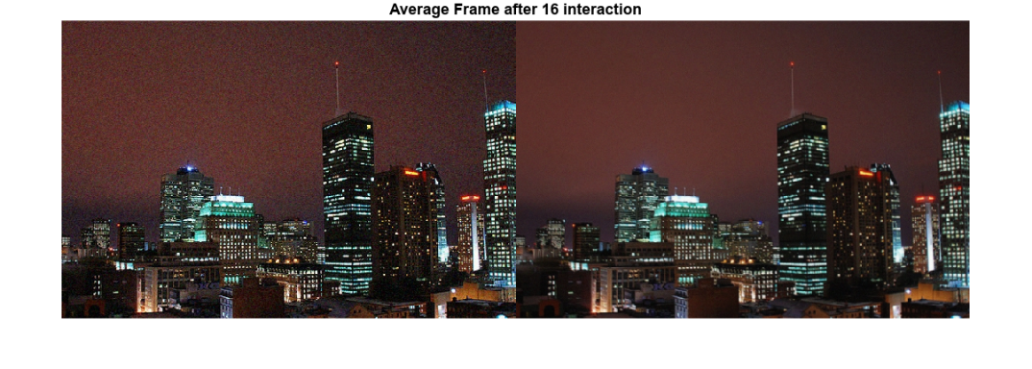

%rect = imrect;

%position = wait(rect);

position = [53 44 258 133];

roi1 = imcrop(Frame, position);

roi2 = imcrop(Frame_Avrg, position);

figure;

subplot(2,2,1);

imshow(roi1);title("Frame");

gray_roi1 = rgb2gray(roi1);

subplot(2,2,3);

imshow(roi2);title("Frame_Average");

gray_roi2 = rgb2gray(roi2);

subplot(2,2,2);

hist(gray_roi1);title("Frame hist");

subplot(2,2,4);

hist(gray_roi2);title("Frame_Average hist");



ניתן לראות שההיסטוגרמה הפכה לצרה יותר לאחר המיצוע ובכך ניתן להבין שנפטרנו מהרעש הלא רצוי כמו כן ניתן לראות שערכי ההיסטוגרמה נמוכים יותר.

# Q3

figure;

frame=rgb2gray(Frame_Avrg);

dx=-4; %pixels

dy=-4; %pixels

theta = -3;

tform = affine2d([ ...

cosd(theta) sind(theta) 0;...

-sind(theta) cosd(theta) 0; ...

dx dy 1])

tform =

affine2d with properties:

T: [3×3 double]

Dimensionality: 2

OutputView = affineOutputView(size(frame),tform,'BoundsStyle','sameAsInput');

Gframe = imwarp(frame,tform, 'FillValues',0,'OutputView',OutputView);

montage({frame,Gframe});

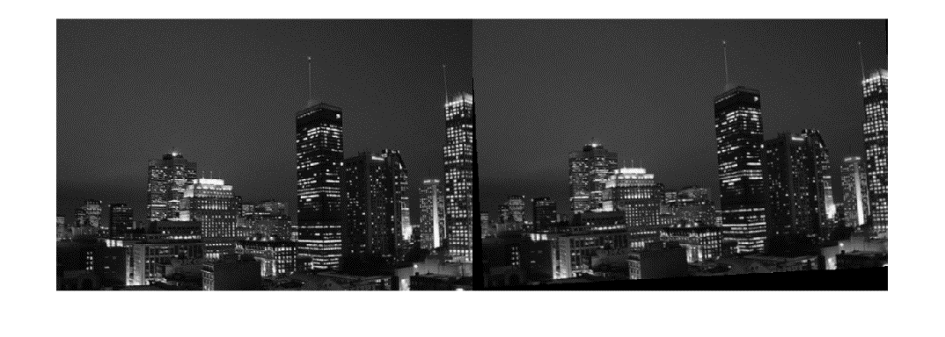

אפשר לראות שהקוד סיבב את התמונה כמו שצפינו.

# Q4

Create 2-D Affine Transformation

Define a 3-by-3 geometric transformation matrix. This example specifies a matrix for an affine transformation consisting of vertical shear and horizontal stretch.

A = [2 0 0; 0.33 1 0; 0 0 1];

tform = affinetform2d(A)

tform =

affinetform2d with properties:

Dimensionality: 2

A: [3×3 double]

I = imread("pout.tif");

imshow(I)



J = imwarp(I,tform);

imshow(J);



Apply Horizontal Shear to Image

Read and display a grayscale image.

I = imread('cameraman.tif');

imshow(I)



Create a 2-D affine transformation.

A = [1 0.5 0; 0 1 0; 0 0 1];

tform = affinetform2d(A);

Apply the transformation to the image.

J = imwarp(I,tform);

imshow(J)



*Copyright 2015-2022 The MathWorks, Inc.*

Warp Image Using Different Output View Styles

Read and display an image. To see the spatial extents of the image, make the axes visible.

A = imread("kobi.png");

A = imresize(A,0.25);

iptsetpref("ImshowAxesVisible","on")

imshow(A)



Create a 2-D affine transformation. This example creates a randomized transformation that consists of scale by a factor in the range [1.2, 2.4], rotation by an angle in the range [-45, 45] degrees, and horizontal translation by a distance in the range [100, 200] pixels.

tform = randomAffine2d("Scale",[1.2,2.4],"XTranslation",[100 200],"Rotation",[-45,45]);

centerOutput = affineOutputView(size(A),tform,"BoundsStyle","CenterOutput");

followOutput = affineOutputView(size(A),tform,"BoundsStyle","FollowOutput");

sameAsInput = affineOutputView(size(A),tform,"BoundsStyle","SameAsInput");

BCenterOutput = imwarp(A,tform,"OutputView",centerOutput);

BFollowOutput = imwarp(A,tform,"OutputView",followOutput);

BSameAsInput = imwarp(A,tform,"OutputView",sameAsInput);

imshow(BCenterOutput)

title("CenterOutput Bounds Style");



imshow(BFollowOutput)

title("FollowOutput Bounds Style");



imshow(BSameAsInput)

title("SameAsInput Bounds Style");



iptsetpref("ImshowAxesVisible","off")

*הפונקציה affineOutputView מחשבת את גודל התמונה החדשה לאחר הטרנספורמציה הגיאומטרית בהינתן גודל התמונה המקורית והטרנספורמציה הגיאומטרית הרצויה, כך שהתמונה לא תיחתך או תאבד מידע רצוי עקב הטרנספורמציה.*